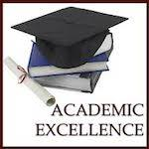
2022-23
Iowa Star Conference
All-Academic Qualifier

The Iowa Star Conference All-Academic award is given to students for their academic excellence. The following student is being recognized for maintaining a minimum 3.25 grade point average over the past Semester / Trimester. This student exemplifies the excellence achieved by young people of today and the future of tomorrow. Congratulations!

Adelyn Sienknecht

Volleyball 2022-23

___Brittany Raymond___________________ ____Carely Epling__________________
Athletic Director Volleyball Coach

